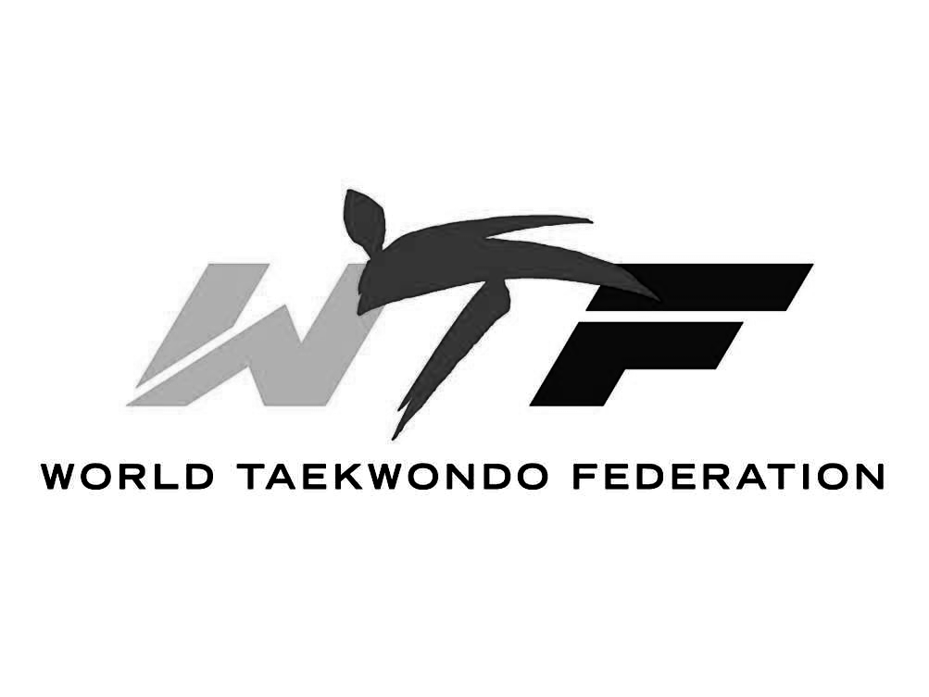



PLEASE RETURN THIS FORM BEFORE THE PROMOTION TEST.
WORLD TAEKWONDO FEDERRATION APPLICATION FOR BELT PROMOTION TEST.
Name : Age : Please circle one: Male Female
Present Belt : Desired(Next) Belt :
I, as student/guardian, submit this for a promotion test in accordance with the promotion regulation of the World Taekwondo Federation.
* Student or Guardian's Signature

So that we may become more familiar with our students, please take a couple of minutes to fill out this form.
Box 1 : Please give us 2 examples of how your child displays at home or school.
(I.e., "John" helped with dishes last week, or "John" fought less with his sister.)
Box 2 : Please give us 2 examples of how your child can improve at home or school.
(I.e., I would like "Jane" to make her bed in the morning, or "Jane" needs to study more to get better grades.)
Box 3 : This is the box to "grade" your child's overall behavior. Please mark accordingly.
Behavior | 1 2 3 4 5 6
Attitude | 1 2 3 4 5 6
Cooperativeness | 1 2 3 4 5 6
Respect for other | 1 2 3 4 5 6
Overall rating | 1 2 3 4 5 6
PLACE THE RED TAPE
ON HIS OR HER BELT OR UNIFORM.

R E S P E C T

1 Excellent 2 Very Good 3 Good 4 Average 5 Poor 6 Very Poor

I herby declare the person above is eligible to be promoted in a test conducted by the World Taekwondo Federation at World Champion Taekwondo.
*Master Kibum Jang

***********************For Masters use only.***********************
EVENT | MENTAL, SPIRITUAL, AND PHYSICAL SATATE | Points | Comments
FORM | Coordination, Breath Control, Balance, Stance, Focus, And composure
SELF-DEFENCE | Concentration, Confidence, Composure, Timing, Speed, And Execution
KICK / FREE SPARRING | Composure, Control, Speed, Balance, Accuracy, KI - HAP!
BREAKING TECHNIQUE | Confidence, Power, Speed, Focus, Accuracy, KI-HAP!
TRAINING ATTITUDE | Respect, Sincerity, Manner, Endurance, and Courage
SCORING SYSTEM A+ (Perfect) A (Excellent) B+ (Great) B( Average) C (Fair) D (Re-Test)
World Champion Taekwondo is affiliated with: United States TKD Union Group,
a Member of US Olympic Committee, and member of Pan/America TKD Union.

